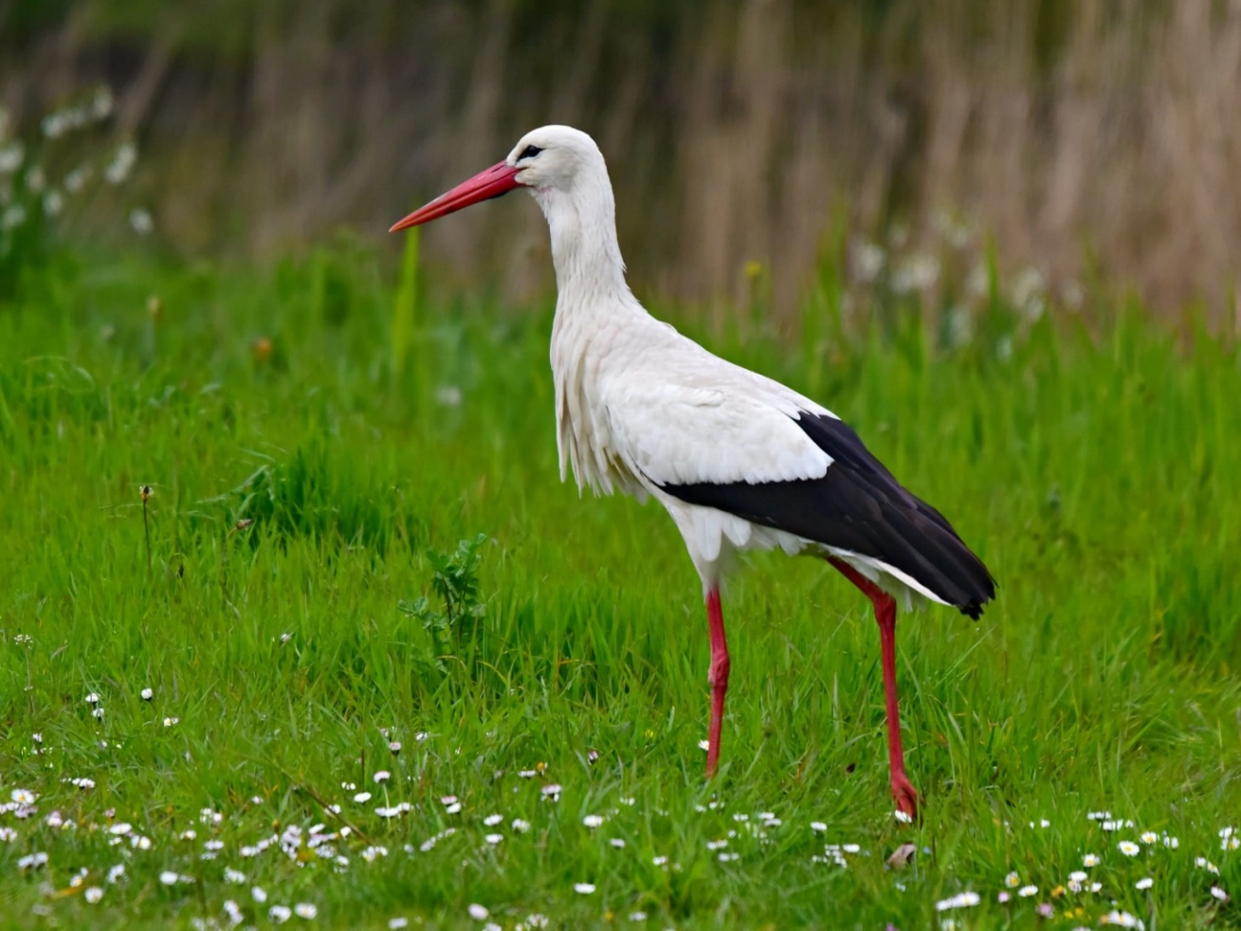

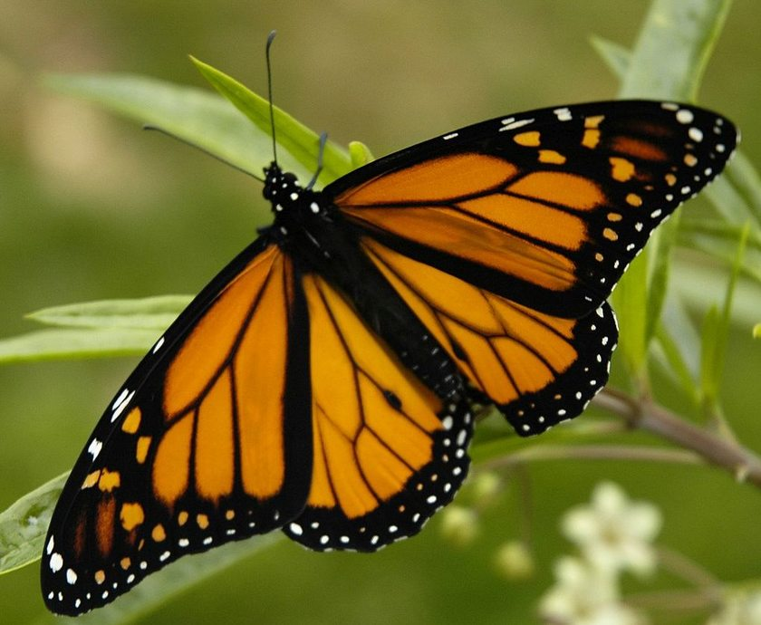

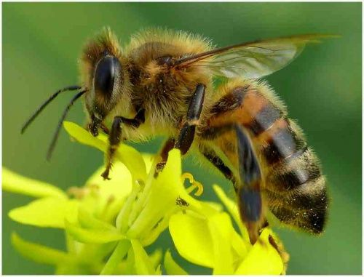

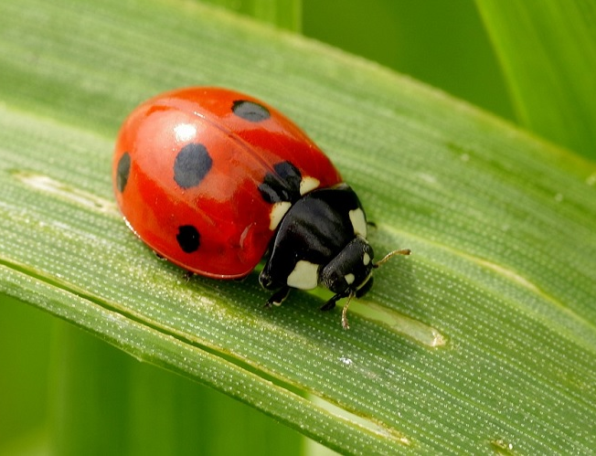

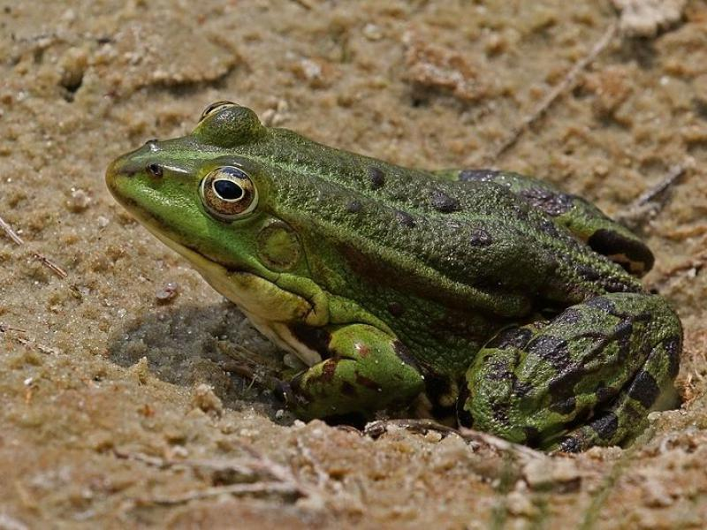

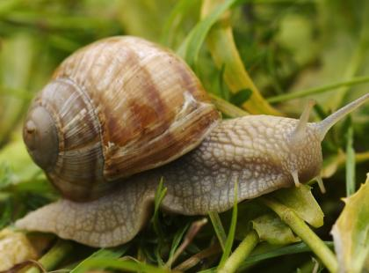

|  |  |
| --- | --- |
| **b** | **ś** |
| **b** | **ż** |
| **m** | **p** |

|  |
| --- |
| **biedronka** |
| **bocian** |
| **żaba** |
| **motyl** |
| **pszczoła** |
| **ślimak** |